[[](https://www.google.co.in/search?rlz=1C1AOHY_enIN712IN712&espv=2&biw=1024&bih=677&tbm=isch&q=construction+project+management&sa=X&ved=0ahUKEwjy9fbG7svRAhWFqo8KHeOGA54QhyYIGg)](https://www.google.co.in/search?rlz=1C1AOHY_enIN712IN712&espv=2&biw=1024&bih=677&tbm=isch&q=construction+project+management&sa=X&ved=0ahUKEwjy9fbG7svRAhWFqo8KHeOGA54QhyYIGg)

[[](https://www.google.co.in/search?rlz=1C1AOHY_enIN712IN712&espv=2&biw=1024&bih=677&tbm=isch&q=construction+project+management&sa=X&ved=0ahUKEwjy9fbG7svRAhWFqo8KHeOGA54QhyYIGg)](https://www.google.co.in/search?rlz=1C1AOHY_enIN712IN712&espv=2&biw=1024&bih=677&tbm=isch&q=construction+project+management&sa=X&ved=0ahUKEwjy9fbG7svRAhWFqo8KHeOGA54QhyYIGg)

[[](https://www.google.co.in/search?rlz=1C1AOHY_enIN712IN712&espv=2&biw=1024&bih=677&tbm=isch&q=construction+project+management&sa=X&ved=0ahUKEwjy9fbG7svRAhWFqo8KHeOGA54QhyYIGg)](https://www.google.co.in/search?rlz=1C1AOHY_enIN712IN712&espv=2&biw=1024&bih=677&tbm=isch&q=construction+project+management&sa=X&ved=0ahUKEwjy9fbG7svRAhWFqo8KHeOGA54QhyYIGg)

[Project](https://www.google.co.in/search?rlz=1C1AOHY_enIN712IN712&espv=2&biw=1024&bih=677&tbm=isch&q=construction+project+management&sa=X&ved=0ahUKEwjy9fbG7svRAhWFqo8KHeOGA54QhyYIGg)

[[](https://www.google.co.in/search?rlz=1C1AOHY_enIN712IN712&espv=2&biw=1024&bih=677&tbm=isch&q=construction+management+clipart&sa=X&ved=0ahUKEwjy9fbG7svRAhWFqo8KHeOGA54QhyYIHQ)](https://www.google.co.in/search?rlz=1C1AOHY_enIN712IN712&espv=2&biw=1024&bih=677&tbm=isch&q=construction+management+clipart&sa=X&ved=0ahUKEwjy9fbG7svRAhWFqo8KHeOGA54QhyYIHQ)

[[](https://www.google.co.in/search?rlz=1C1AOHY_enIN712IN712&espv=2&biw=1024&bih=677&tbm=isch&q=construction+management+clipart&sa=X&ved=0ahUKEwjy9fbG7svRAhWFqo8KHeOGA54QhyYIHQ)](https://www.google.co.in/search?rlz=1C1AOHY_enIN712IN712&espv=2&biw=1024&bih=677&tbm=isch&q=construction+management+clipart&sa=X&ved=0ahUKEwjy9fbG7svRAhWFqo8KHeOGA54QhyYIHQ)

[[](https://www.google.co.in/search?rlz=1C1AOHY_enIN712IN712&espv=2&biw=1024&bih=677&tbm=isch&q=construction+management+clipart&sa=X&ved=0ahUKEwjy9fbG7svRAhWFqo8KHeOGA54QhyYIHQ)](https://www.google.co.in/search?rlz=1C1AOHY_enIN712IN712&espv=2&biw=1024&bih=677&tbm=isch&q=construction+management+clipart&sa=X&ved=0ahUKEwjy9fbG7svRAhWFqo8KHeOGA54QhyYIHQ)

[[](https://www.google.co.in/search?rlz=1C1AOHY_enIN712IN712&espv=2&biw=1024&bih=677&tbm=isch&q=construction+management+clipart&sa=X&ved=0ahUKEwjy9fbG7svRAhWFqo8KHeOGA54QhyYIHQ)](https://www.google.co.in/search?rlz=1C1AOHY_enIN712IN712&espv=2&biw=1024&bih=677&tbm=isch&q=construction+management+clipart&sa=X&ved=0ahUKEwjy9fbG7svRAhWFqo8KHeOGA54QhyYIHQ)

[Clipart](https://www.google.co.in/search?rlz=1C1AOHY_enIN712IN712&espv=2&biw=1024&bih=677&tbm=isch&q=construction+management+clipart&sa=X&ved=0ahUKEwjy9fbG7svRAhWFqo8KHeOGA54QhyYIHQ)

[[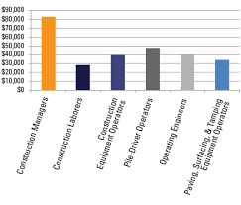](https://www.google.co.in/search?rlz=1C1AOHY_enIN712IN712&espv=2&biw=1024&bih=677&tbm=isch&q=construction+management+salary&sa=X&ved=0ahUKEwjy9fbG7svRAhWFqo8KHeOGA54QhyYIIA)](https://www.google.co.in/search?rlz=1C1AOHY_enIN712IN712&espv=2&biw=1024&bih=677&tbm=isch&q=construction+management+salary&sa=X&ved=0ahUKEwjy9fbG7svRAhWFqo8KHeOGA54QhyYIIA)

[[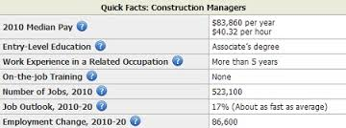](https://www.google.co.in/search?rlz=1C1AOHY_enIN712IN712&espv=2&biw=1024&bih=677&tbm=isch&q=construction+management+salary&sa=X&ved=0ahUKEwjy9fbG7svRAhWFqo8KHeOGA54QhyYIIA)](https://www.google.co.in/search?rlz=1C1AOHY_enIN712IN712&espv=2&biw=1024&bih=677&tbm=isch&q=construction+management+salary&sa=X&ved=0ahUKEwjy9fbG7svRAhWFqo8KHeOGA54QhyYIIA)

[[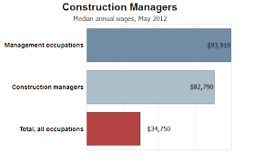](https://www.google.co.in/search?rlz=1C1AOHY_enIN712IN712&espv=2&biw=1024&bih=677&tbm=isch&q=construction+management+salary&sa=X&ved=0ahUKEwjy9fbG7svRAhWFqo8KHeOGA54QhyYIIA)](https://www.google.co.in/search?rlz=1C1AOHY_enIN712IN712&espv=2&biw=1024&bih=677&tbm=isch&q=construction+management+salary&sa=X&ved=0ahUKEwjy9fbG7svRAhWFqo8KHeOGA54QhyYIIA)

[Salary](https://www.google.co.in/search?rlz=1C1AOHY_enIN712IN712&espv=2&biw=1024&bih=677&tbm=isch&q=construction+management+salary&sa=X&ved=0ahUKEwjy9fbG7svRAhWFqo8KHeOGA54QhyYIIA)

[[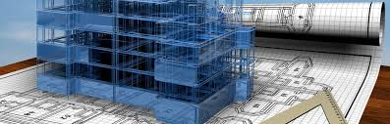](https://www.google.co.in/search?rlz=1C1AOHY_enIN712IN712&espv=2&biw=1024&bih=677&tbm=isch&q=construction+management+banner&sa=X&ved=0ahUKEwjy9fbG7svRAhWFqo8KHeOGA54QhyYIIw)](https://www.google.co.in/search?rlz=1C1AOHY_enIN712IN712&espv=2&biw=1024&bih=677&tbm=isch&q=construction+management+banner&sa=X&ved=0ahUKEwjy9fbG7svRAhWFqo8KHeOGA54QhyYIIw)

[[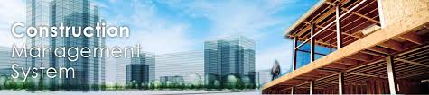](https://www.google.co.in/search?rlz=1C1AOHY_enIN712IN712&espv=2&biw=1024&bih=677&tbm=isch&q=construction+management+banner&sa=X&ved=0ahUKEwjy9fbG7svRAhWFqo8KHeOGA54QhyYIIw)](https://www.google.co.in/search?rlz=1C1AOHY_enIN712IN712&espv=2&biw=1024&bih=677&tbm=isch&q=construction+management+banner&sa=X&ved=0ahUKEwjy9fbG7svRAhWFqo8KHeOGA54QhyYIIw)

[[](https://www.google.co.in/search?rlz=1C1AOHY_enIN712IN712&espv=2&biw=1024&bih=677&tbm=isch&q=construction+management+banner&sa=X&ved=0ahUKEwjy9fbG7svRAhWFqo8KHeOGA54QhyYIIw)](https://www.google.co.in/search?rlz=1C1AOHY_enIN712IN712&espv=2&biw=1024&bih=677&tbm=isch&q=construction+management+banner&sa=X&ved=0ahUKEwjy9fbG7svRAhWFqo8KHeOGA54QhyYIIw)

[Banner](https://www.google.co.in/search?rlz=1C1AOHY_enIN712IN712&espv=2&biw=1024&bih=677&tbm=isch&q=construction+management+banner&sa=X&ved=0ahUKEwjy9fbG7svRAhWFqo8KHeOGA54QhyYIIw)

[[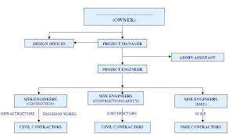](https://www.google.co.in/search?rlz=1C1AOHY_enIN712IN712&espv=2&biw=1024&bih=677&tbm=isch&q=construction+management+chart&sa=X&ved=0ahUKEwjy9fbG7svRAhWFqo8KHeOGA54QhyYIJg)](https://www.google.co.in/search?rlz=1C1AOHY_enIN712IN712&espv=2&biw=1024&bih=677&tbm=isch&q=construction+management+chart&sa=X&ved=0ahUKEwjy9fbG7svRAhWFqo8KHeOGA54QhyYIJg)

[[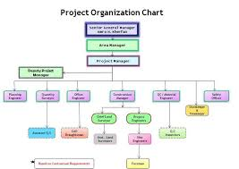](https://www.google.co.in/search?rlz=1C1AOHY_enIN712IN712&espv=2&biw=1024&bih=677&tbm=isch&q=construction+management+chart&sa=X&ved=0ahUKEwjy9fbG7svRAhWFqo8KHeOGA54QhyYIJg)](https://www.google.co.in/search?rlz=1C1AOHY_enIN712IN712&espv=2&biw=1024&bih=677&tbm=isch&q=construction+management+chart&sa=X&ved=0ahUKEwjy9fbG7svRAhWFqo8KHeOGA54QhyYIJg)

[[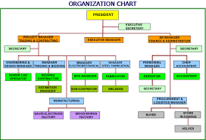](https://www.google.co.in/search?rlz=1C1AOHY_enIN712IN712&espv=2&biw=1024&bih=677&tbm=isch&q=construction+management+chart&sa=X&ved=0ahUKEwjy9fbG7svRAhWFqo8KHeOGA54QhyYIJg)](https://www.google.co.in/search?rlz=1C1AOHY_enIN712IN712&espv=2&biw=1024&bih=677&tbm=isch&q=construction+management+chart&sa=X&ved=0ahUKEwjy9fbG7svRAhWFqo8KHeOGA54QhyYIJg)

[Chart](https://www.google.co.in/search?rlz=1C1AOHY_enIN712IN712&espv=2&biw=1024&bih=677&tbm=isch&q=construction+management+chart&sa=X&ved=0ahUKEwjy9fbG7svRAhWFqo8KHeOGA54QhyYIJg)

[[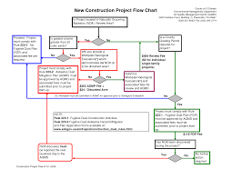](https://www.google.co.in/search?rlz=1C1AOHY_enIN712IN712&espv=2&biw=1024&bih=677&tbm=isch&q=construction+project+management+flow+chart&sa=X&ved=0ahUKEwjy9fbG7svRAhWFqo8KHeOGA54QhyYIKQ)](https://www.google.co.in/search?rlz=1C1AOHY_enIN712IN712&espv=2&biw=1024&bih=677&tbm=isch&q=construction+project+management+flow+chart&sa=X&ved=0ahUKEwjy9fbG7svRAhWFqo8KHeOGA54QhyYIKQ)

[[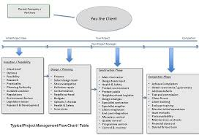](https://www.google.co.in/search?rlz=1C1AOHY_enIN712IN712&espv=2&biw=1024&bih=677&tbm=isch&q=construction+project+management+flow+chart&sa=X&ved=0ahUKEwjy9fbG7svRAhWFqo8KHeOGA54QhyYIKQ)](https://www.google.co.in/search?rlz=1C1AOHY_enIN712IN712&espv=2&biw=1024&bih=677&tbm=isch&q=construction+project+management+flow+chart&sa=X&ved=0ahUKEwjy9fbG7svRAhWFqo8KHeOGA54QhyYIKQ)

[[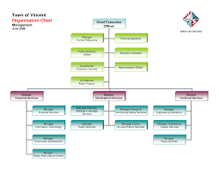](https://www.google.co.in/search?rlz=1C1AOHY_enIN712IN712&espv=2&biw=1024&bih=677&tbm=isch&q=construction+project+management+flow+chart&sa=X&ved=0ahUKEwjy9fbG7svRAhWFqo8KHeOGA54QhyYIKQ)](https://www.google.co.in/search?rlz=1C1AOHY_enIN712IN712&espv=2&biw=1024&bih=677&tbm=isch&q=construction+project+management+flow+chart&sa=X&ved=0ahUKEwjy9fbG7svRAhWFqo8KHeOGA54QhyYIKQ)

[Project Management Flow Chart](https://www.google.co.in/search?rlz=1C1AOHY_enIN712IN712&espv=2&biw=1024&bih=677&tbm=isch&q=construction+project+management+flow+chart&sa=X&ved=0ahUKEwjy9fbG7svRAhWFqo8KHeOGA54QhyYIKQ)

**Search Results**

[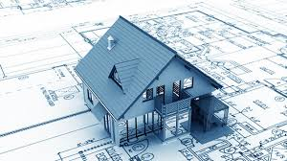](https://www.google.co.in/imgres?imgurl=http://www.chorius.com/wp-content/uploads/2016/05/ConstructionManagement.jpg&imgrefurl=http://www.chorius.com/specialisation/construction-management/&docid=fbzgxISW8ALo7M&tbnid=VY95EfAqgQxcuM:&vet=1&w=631&h=354&bih=677&biw=1024&q=construction%20management&ved=0ahUKEwjy9fbG7svRAhWFqo8KHeOGA54QMwg5KAkwCQ&iact=mrc&uact=8)

[](https://www.google.co.in/imgres?imgurl=http://iteksolns.com/images/Construction3big.jpg&imgrefurl=http://iteksolns.com/Product/Product_Construction&docid=ZjYQbRQxyYCq6M&tbnid=jPJPUcIpcnRy_M:&vet=1&w=920&h=613&bih=677&biw=1024&q=construction%20management&ved=0ahUKEwjy9fbG7svRAhWFqo8KHeOGA54QMwg6KAowCg&iact=mrc&uact=8)

[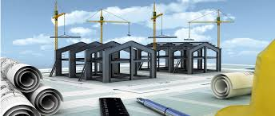](https://www.google.co.in/imgres?imgurl=http://www.vision360.co/wp-content/uploads/2014/09/Services_-_Construction_Management.jpg&imgrefurl=http://www.vision360.co/construction-management/&docid=lAdvUWKfFHaMvM&tbnid=w6hqjGbH87E9UM:&vet=1&w=1170&h=498&bih=677&biw=1024&q=construction%20management&ved=0ahUKEwjy9fbG7svRAhWFqo8KHeOGA54QMwg7KAswCw&iact=mrc&uact=8)

[](https://www.google.co.in/imgres?imgurl=https://www.bls.gov/ooh/images/1638.jpg&imgrefurl=https://www.bls.gov/ooh/management/construction-managers.htm&docid=L6rnxuEceLxQzM&tbnid=yAIaRmD4nE8v8M:&vet=1&w=336&h=240&bih=677&biw=1024&q=construction%20management&ved=0ahUKEwjy9fbG7svRAhWFqo8KHeOGA54QMwg8KAwwDA&iact=mrc&uact=8)

[](https://www.google.co.in/imgres?imgurl=http://www.adamsrants.com/file/2016/07/construction_management_9805764-655x280.jpg&imgrefurl=http://www.adamsrants.com/construction-management/&docid=4NZz4ce4ANtVVM&tbnid=CQ6IbNEFPOJthM:&vet=1&w=655&h=280&bih=677&biw=1024&q=construction%20management&ved=0ahUKEwjy9fbG7svRAhWFqo8KHeOGA54QMwg9KA0wDQ&iact=mrc&uact=8)

[](https://www.google.co.in/imgres?imgurl=http://www.srsa-realestate.com/graphics/2012/ConstructionManagement.jpg&imgrefurl=http://www.srsa-realestate.com/construction.html&docid=lD0edfOyRrI-SM&tbnid=aQ9243IJLCJAxM:&vet=1&w=600&h=235&bih=677&biw=1024&q=construction%20management&ved=0ahUKEwjy9fbG7svRAhWFqo8KHeOGA54QMwg-KA4wDg&iact=mrc&uact=8)

[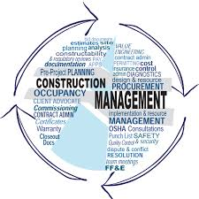](https://www.google.co.in/imgres?imgurl=http://www.pdeblasiobuilders.com/commercial/wp-content/uploads/construction-management-word-img.jpg&imgrefurl=http://www.pdeblasiobuilders.com/commercial/construction-management/&docid=6teZ6KlnQz6YZM&tbnid=_1OXju7j589g8M:&vet=1&w=600&h=600&bih=677&biw=1024&q=construction%20management&ved=0ahUKEwjy9fbG7svRAhWFqo8KHeOGA54QMwg_KA8wDw&iact=mrc&uact=8)

[](https://www.google.co.in/imgres?imgurl=http://www.schoolanduniversity.com/images/page_uploads/Construction_Management.jpg&imgrefurl=http://www.schoolanduniversity.com/study-programs/trade-vocational/construction-management&docid=m-EYtyv2ObWQFM&tbnid=xMG6P7_iUniSZM:&vet=1&w=300&h=300&bih=677&biw=1024&q=construction%20management&ved=0ahUKEwjy9fbG7svRAhWFqo8KHeOGA54QMwhAKBAwEA&iact=mrc&uact=8)

[](https://www.google.co.in/imgres?imgurl=http://horizongen.com/wp-content/uploads/2014/11/planning-cropped.jpg&imgrefurl=http://www.horizongen.com/constructionmanagement/&docid=bEukBXl1FUOleM&tbnid=6Wjd8uZDa1O4iM:&vet=1&w=4260&h=2170&bih=677&biw=1024&q=construction%20management&ved=0ahUKEwjy9fbG7svRAhWFqo8KHeOGA54QMwhBKBEwEQ&iact=mrc&uact=8)

[](https://www.google.co.in/imgres?imgurl=http://www.aveoninfotech.com/aveon/images/constructionbanner.jpg&imgrefurl=http://www.aveoninfotech.com/aveon/index.php/aveon-products/construction-management-software&docid=u4k2Y1_GEarChM&tbnid=IJn8DEJcDlGRmM:&vet=1&w=937&h=384&bih=677&biw=1024&q=construction%20management&ved=0ahUKEwjy9fbG7svRAhWFqo8KHeOGA54QMwhCKBIwEg&iact=mrc&uact=8)

[](https://www.google.co.in/imgres?imgurl=http://www.aiplanners.in/wp-content/uploads/2014/04/Constuction2.jpg&imgrefurl=http://www.aiplanners.in/what-we-do/construction-management/&docid=AWARxIysrH8xdM&tbnid=-nphAXPzIovLAM:&vet=1&w=642&h=430&bih=677&biw=1024&q=construction%20management&ved=0ahUKEwjy9fbG7svRAhWFqo8KHeOGA54QMwhDKBMwEw&iact=mrc&uact=8)

[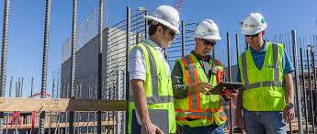](https://www.google.co.in/imgres?imgurl=http://huntconstructiongroup.com/wp-content/uploads/2013/07/construction-management.jpg&imgrefurl=http://huntconstructiongroup.com/services/delivery/construction-management/&docid=Ua0SwIyLSDCG1M&tbnid=n_JHaN00DUcJ6M:&vet=1&w=1280&h=542&bih=677&biw=1024&q=construction%20management&ved=0ahUKEwjy9fbG7svRAhWFqo8KHeOGA54QMwhPKBQwFA&iact=mrc&uact=8)

[](https://www.google.co.in/imgres?imgurl=https://www.buildcolorado.com/sites/default/files/Construction%20Management.jpg&imgrefurl=https://www.buildcolorado.com/construction-management-0&docid=EM_BhW6cr4cRUM&tbnid=NI3ujcMeRsJe3M:&vet=1&w=1200&h=801&bih=677&biw=1024&q=construction%20management&ved=0ahUKEwjy9fbG7svRAhWFqo8KHeOGA54QMwhQKBUwFQ&iact=mrc&uact=8)

[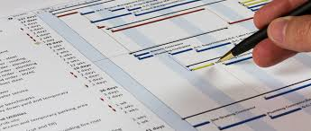](https://www.google.co.in/imgres?imgurl=http://www.cdsmith.com/img/services/construction-management.jpg&imgrefurl=http://www.cdsmith.com/construction-services/construction-management&docid=MeCrzT4EHza6HM&tbnid=0nn1dvfcmwtK2M:&vet=1&w=1170&h=495&bih=677&biw=1024&q=construction%20management&ved=0ahUKEwjy9fbG7svRAhWFqo8KHeOGA54QMwhRKBYwFg&iact=mrc&uact=8)

[](https://www.google.co.in/imgres?imgurl=http://www.kramerausenco.com/scripts/image.php?src=http://www.kramerausenco.com/content/Image/Construction-Management2.jpg&w=950&h=330&imgrefurl=http://www.kramerausenco.com/page/services/construction-management/&docid=n9x_bNPRfKBOwM&tbnid=eC6WqBxTdVyGiM:&vet=1&w=950&h=330&bih=677&biw=1024&q=construction%20management&ved=0ahUKEwjy9fbG7svRAhWFqo8KHeOGA54QMwhSKBcwFw&iact=mrc&uact=8)

[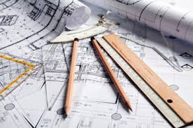](https://www.google.co.in/imgres?imgurl=http://www.godsellcc.com/wp-content/uploads/2012/01/constructionmanagement.jpg&imgrefurl=http://www.godsellcc.com/services/expert-construction-management/&docid=qD7U7mIp28XEPM&tbnid=KsFYA-itNkWtKM:&vet=1&w=375&h=249&bih=677&biw=1024&q=construction%20management&ved=0ahUKEwjy9fbG7svRAhWFqo8KHeOGA54QMwhTKBgwGA&iact=mrc&uact=8)

[](https://www.google.co.in/imgres?imgurl=http://www.bgsu.edu/content/bgsu/en/technology-architecture-and-applied-engineering/departments-and-programs/graduate/construction-management/_jcr_content/top-content-slider-parsys/image.img.jpg/1396032191724.jpg&imgrefurl=http://www.bgsu.edu/technology-architecture-and-applied-engineering/departments-and-programs/graduate/construction-management.html&docid=-s6Il72YXZWTVM&tbnid=qpPdX190iqGjGM:&vet=1&w=850&h=521&bih=677&biw=1024&q=construction%20management&ved=0ahUKEwjy9fbG7svRAhWFqo8KHeOGA54QMwhUKBkwGQ&iact=mrc&uact=8)

[](https://www.google.co.in/imgres?imgurl=http://holtcc.com/wp-content/uploads/2016/02/iStock_000015624575Small2.jpg&imgrefurl=http://holtcc.com/our-services/construction-management/&docid=6vboOnD_0rWhhM&tbnid=5P3iCBUYkEyCoM:&vet=1&w=1440&h=810&bih=677&biw=1024&q=construction%20management&ved=0ahUKEwjy9fbG7svRAhWFqo8KHeOGA54QMwhVKBowGg&iact=mrc&uact=8)

[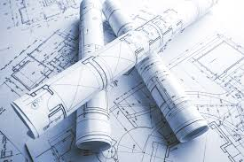](https://www.google.co.in/imgres?imgurl=http://explorecivil.net/wp-content/uploads/2016/03/Construction-Management-Courses.jpg&imgrefurl=https://explorecivil.net/construction-management-courses/&docid=yJBI-I34_y7zvM&tbnid=jxDeZHASlFe0MM:&vet=1&w=1600&h=1065&bih=677&biw=1024&q=construction%20management&ved=0ahUKEwjy9fbG7svRAhWFqo8KHeOGA54QMwhWKBswGw&iact=mrc&uact=8)

[](https://www.google.co.in/imgres?imgurl=http://www.cm.chhs.colostate.edu/img/feature/Teaching-CM-technology.jpg&imgrefurl=http://www.cm.chhs.colostate.edu/&docid=wyJXNM4ntGDvUM&tbnid=X2EiPUjTpuKSbM:&vet=1&w=1500&h=650&bih=677&biw=1024&q=construction%20management&ved=0ahUKEwjy9fbG7svRAhWFqo8KHeOGA54QMwhXKBwwHA&iact=mrc&uact=8)

[](https://www.google.co.in/imgres?imgurl=http://www.ndsatcom.com/gfx/image/system_integration/management/construction_management.jpg&imgrefurl=http://www.ndsatcom.com/en/system_integration/construction_management.php&docid=V8_jaJ85-1DRzM&tbnid=L7NWgEP-9zHM_M:&vet=1&w=1719&h=1105&bih=677&biw=1024&q=construction%20management&ved=0ahUKEwjy9fbG7svRAhWFqo8KHeOGA54QMwhYKB0wHQ&iact=mrc&uact=8)

[](https://www.google.co.in/imgres?imgurl=http://constructionmanagementsalary.com/wp-content/uploads/2012/09/Typical-Construction-Management-Fees.jpg&imgrefurl=http://www.constructionmanagementsalary.com/typical-construction-management-fees-structure-overall-percentage/&docid=7k0V85cFscnccM&tbnid=wSw8g-YqFX0P-M:&vet=1&w=400&h=267&bih=677&biw=1024&q=construction%20management&ved=0ahUKEwjy9fbG7svRAhWFqo8KHeOGA54QMwhZKB4wHg&iact=mrc&uact=8)

[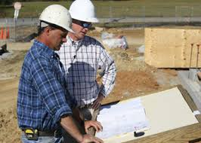](https://www.google.co.in/imgres?imgurl=http://www.ctc.uaf.edu/programs/cm/images/CManagement.jpg&imgrefurl=http://www.ctc.uaf.edu/programs/cm/&docid=NIr0rAVvYzWnfM&tbnid=RxEzMw0MRfo91M:&vet=1&w=350&h=250&bih=677&biw=1024&q=construction%20management&ved=0ahUKEwjy9fbG7svRAhWFqo8KHeOGA54QMwhaKB8wHw&iact=mrc&uact=8) 

 